**SOURCE REPOSITORY ASSIGNMENT-I**

1. **Create a local git repo with the name "MyRepo".**

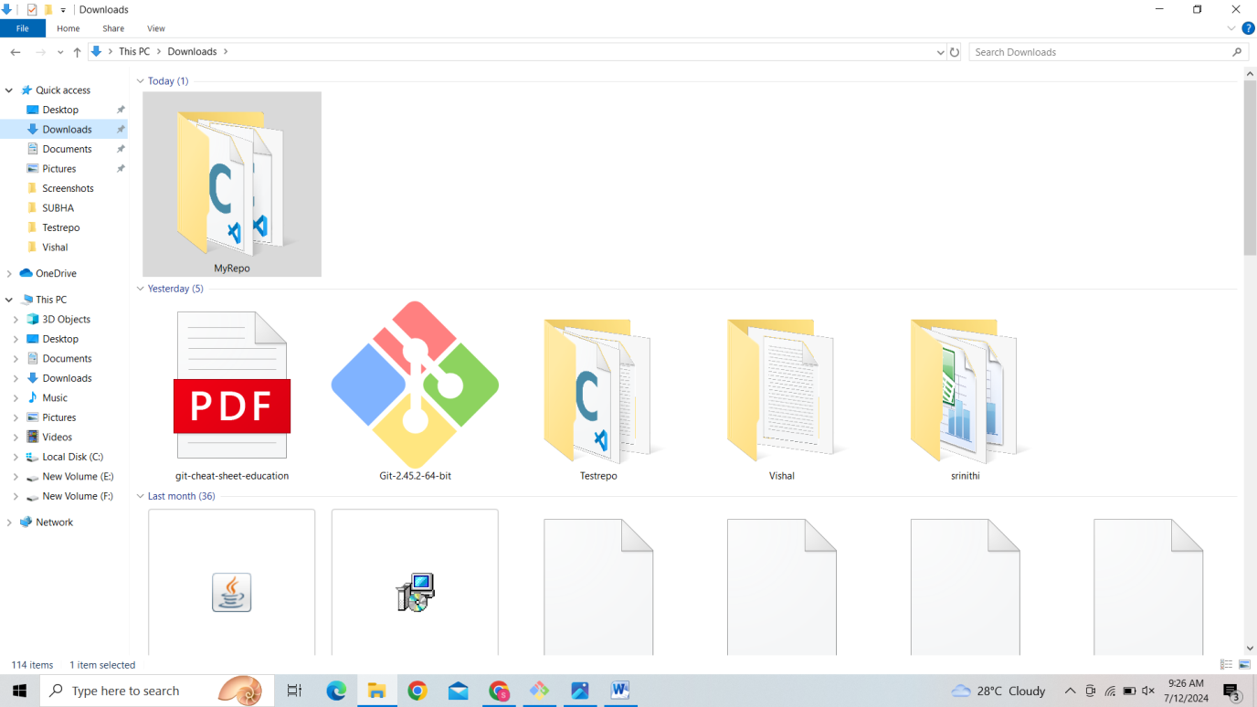

**2. create one .txt file, five .c files and five .java files in the working area.**

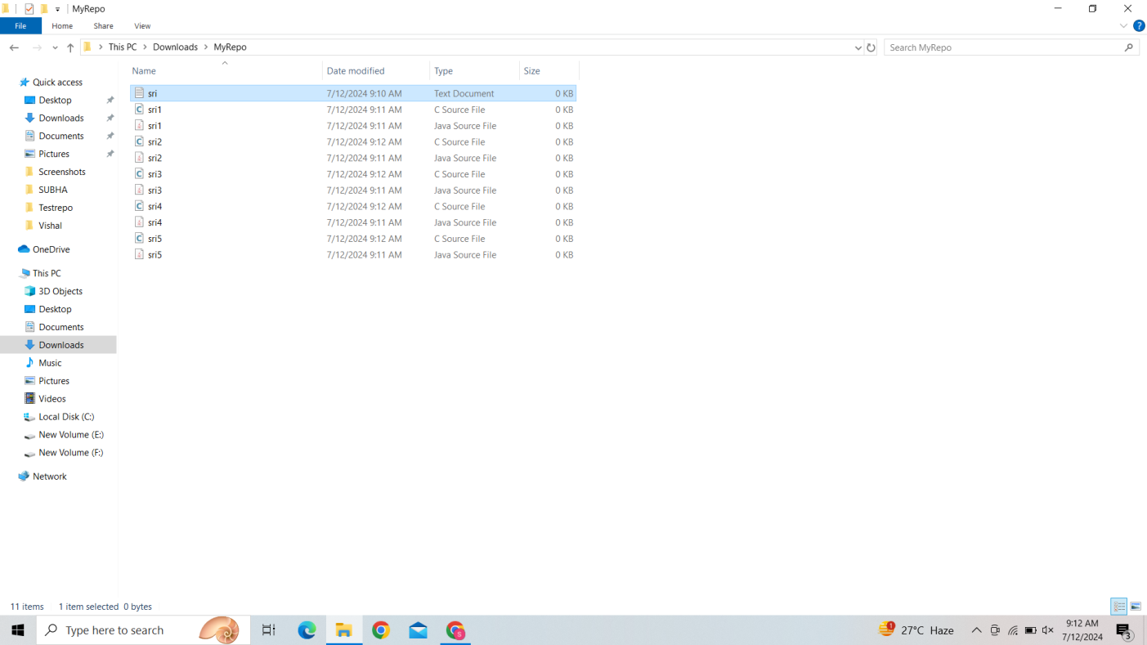

**3.Verify the git status.**

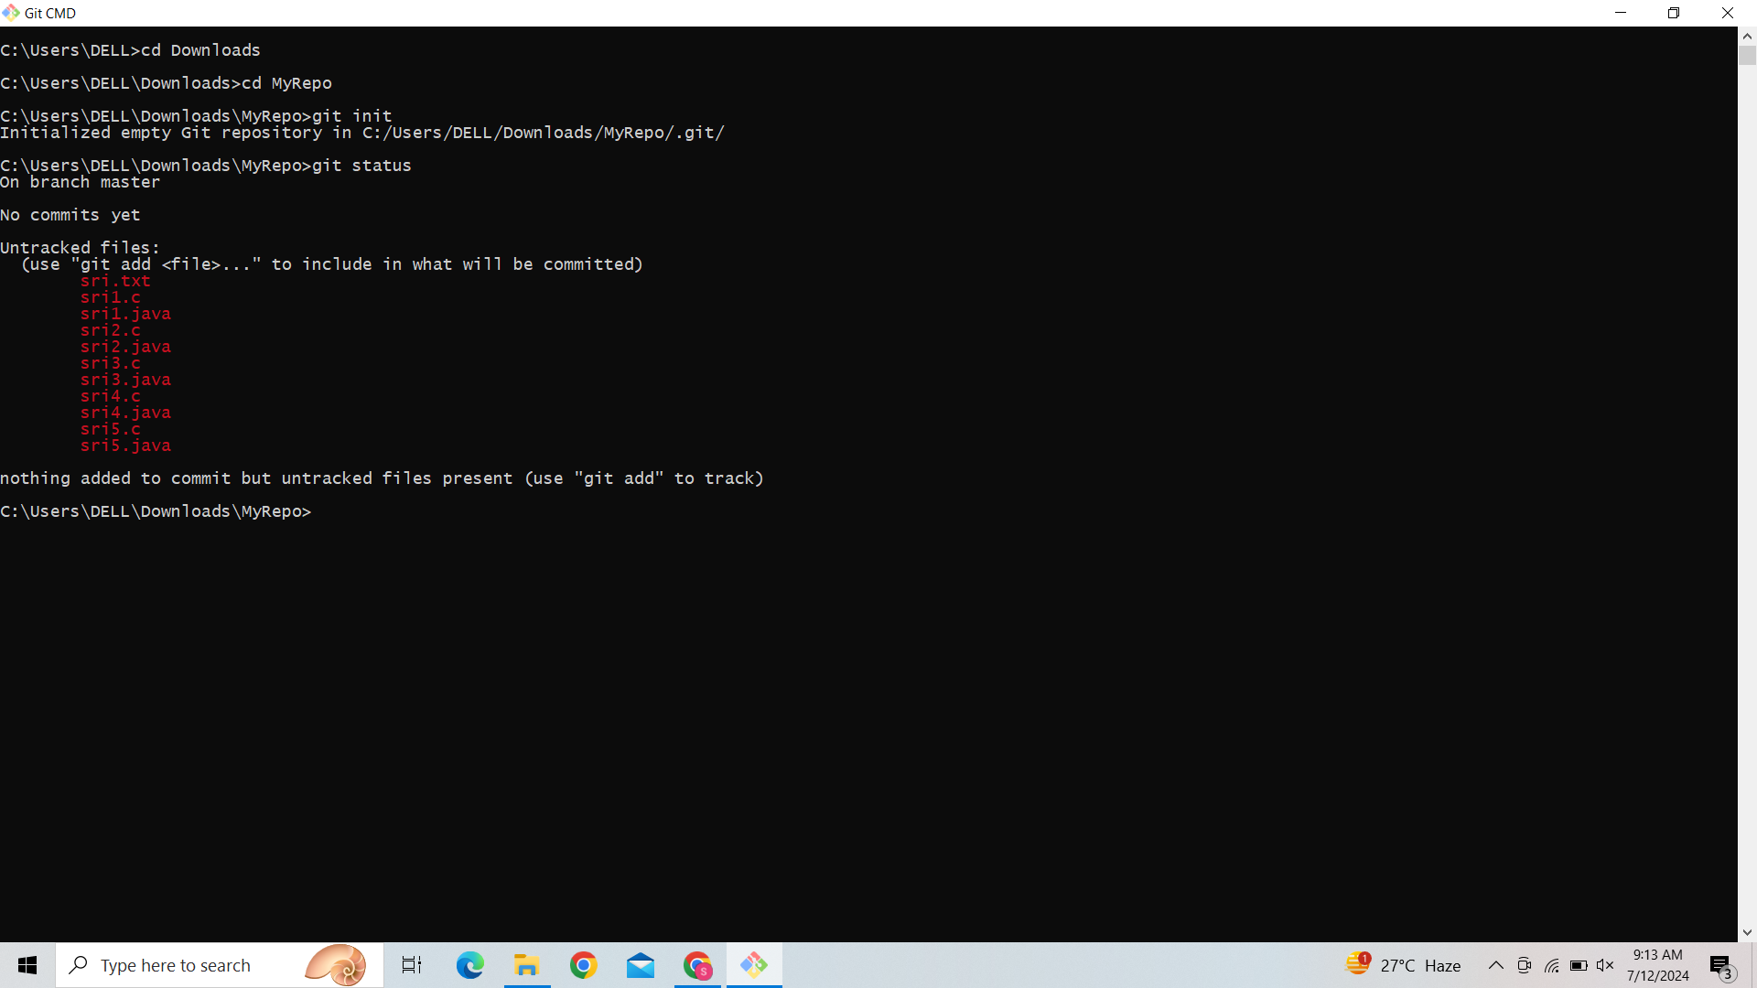

**4.Add only the .txt into the staging area.**

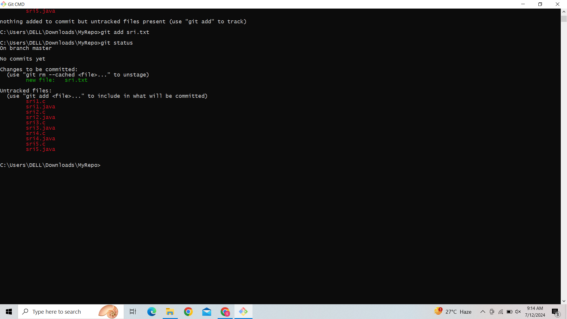

**5.verify the git status.**



**6. Make a commit with the name "TXT Commit".**

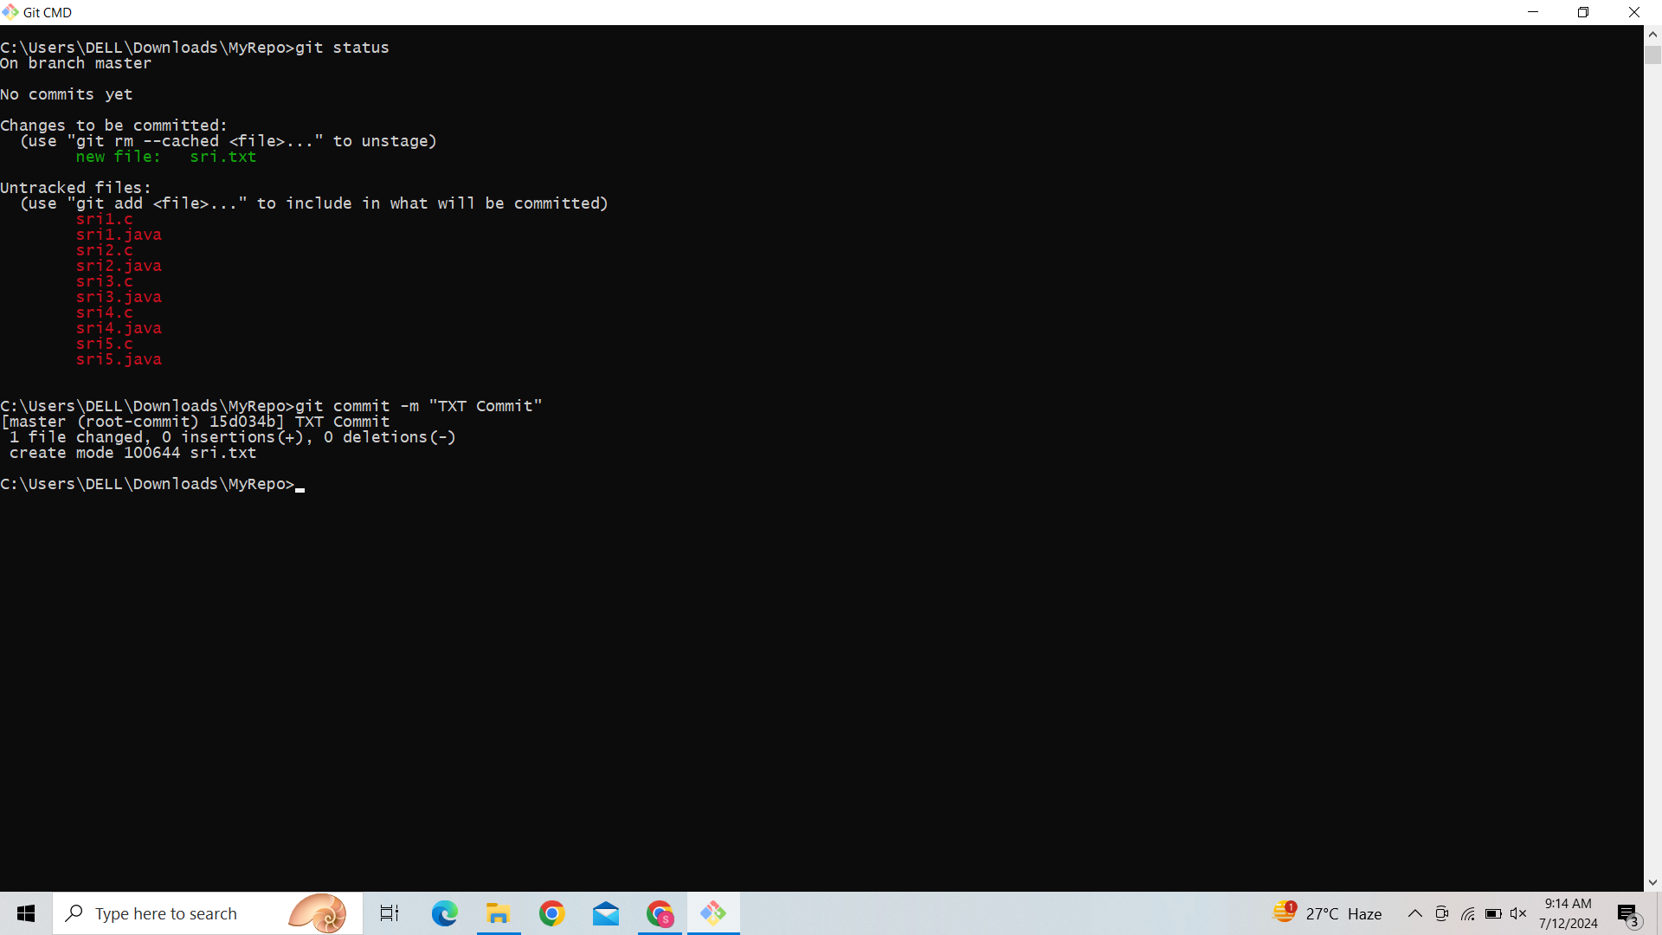

**7. Add all .c files into the staging area.**

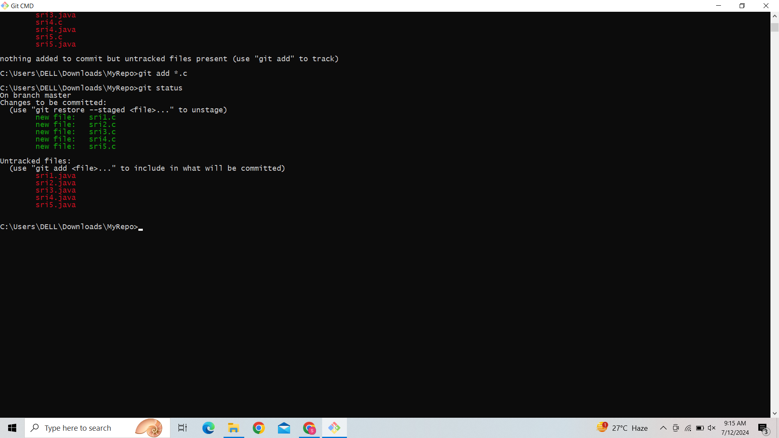

**8.** **verify the git status.**

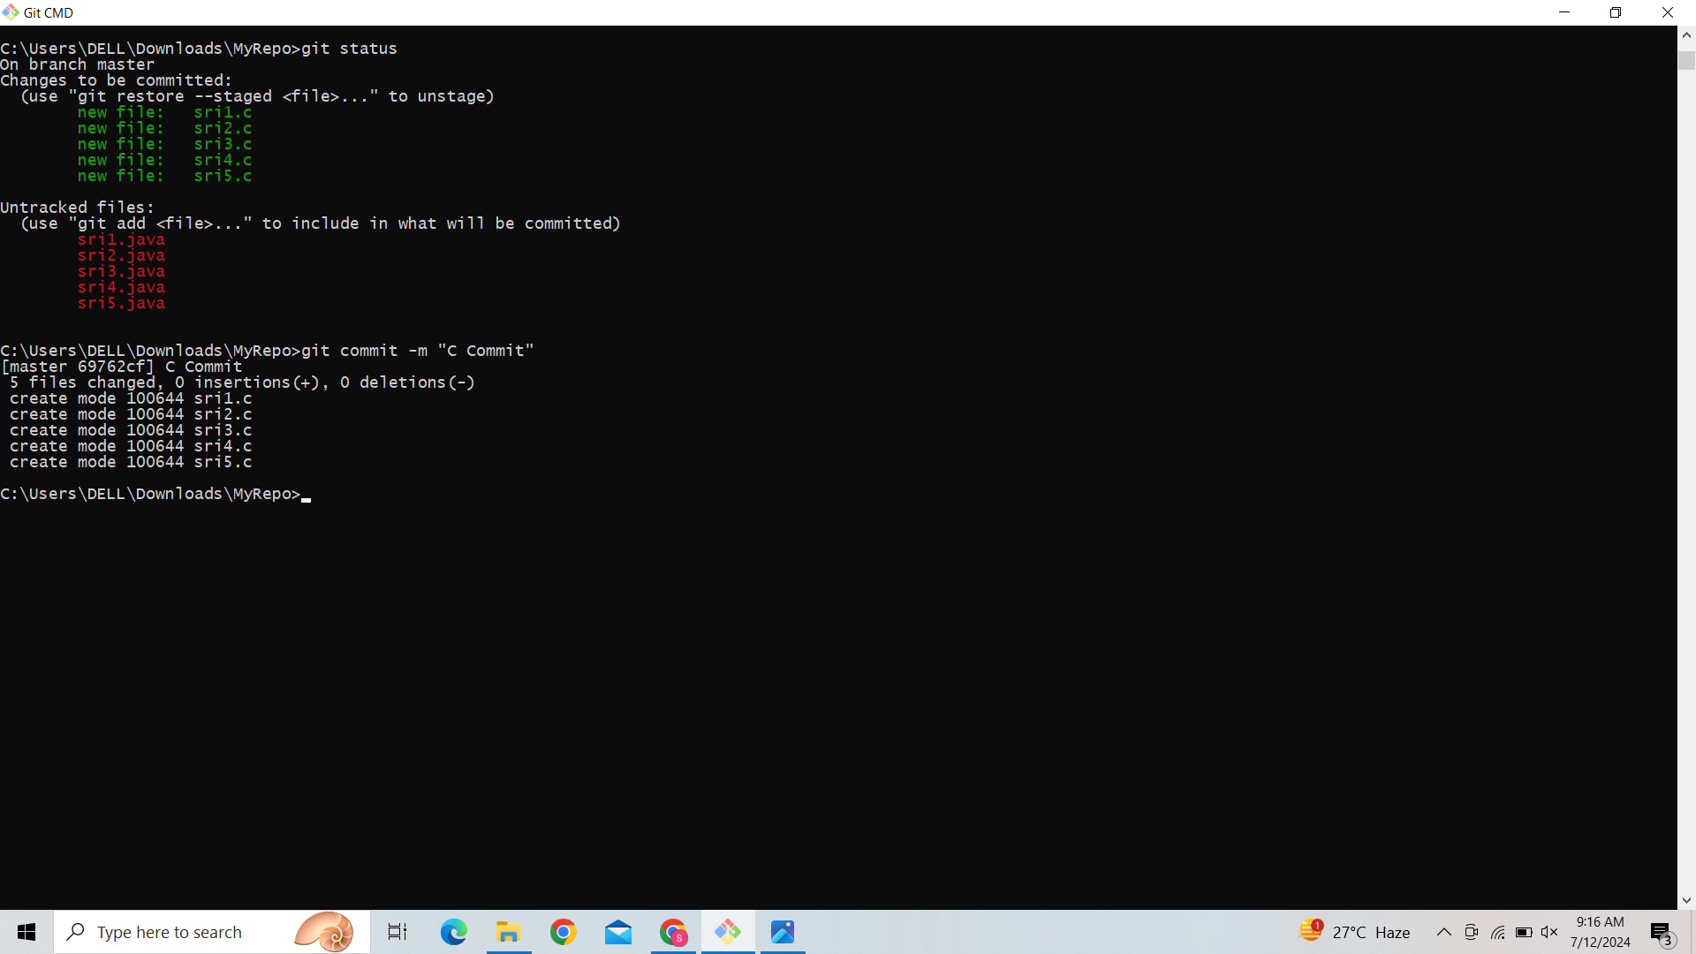

**9.Make a commit with the name "C Commit".**



**10.** **Add all .java files into the staging area.**

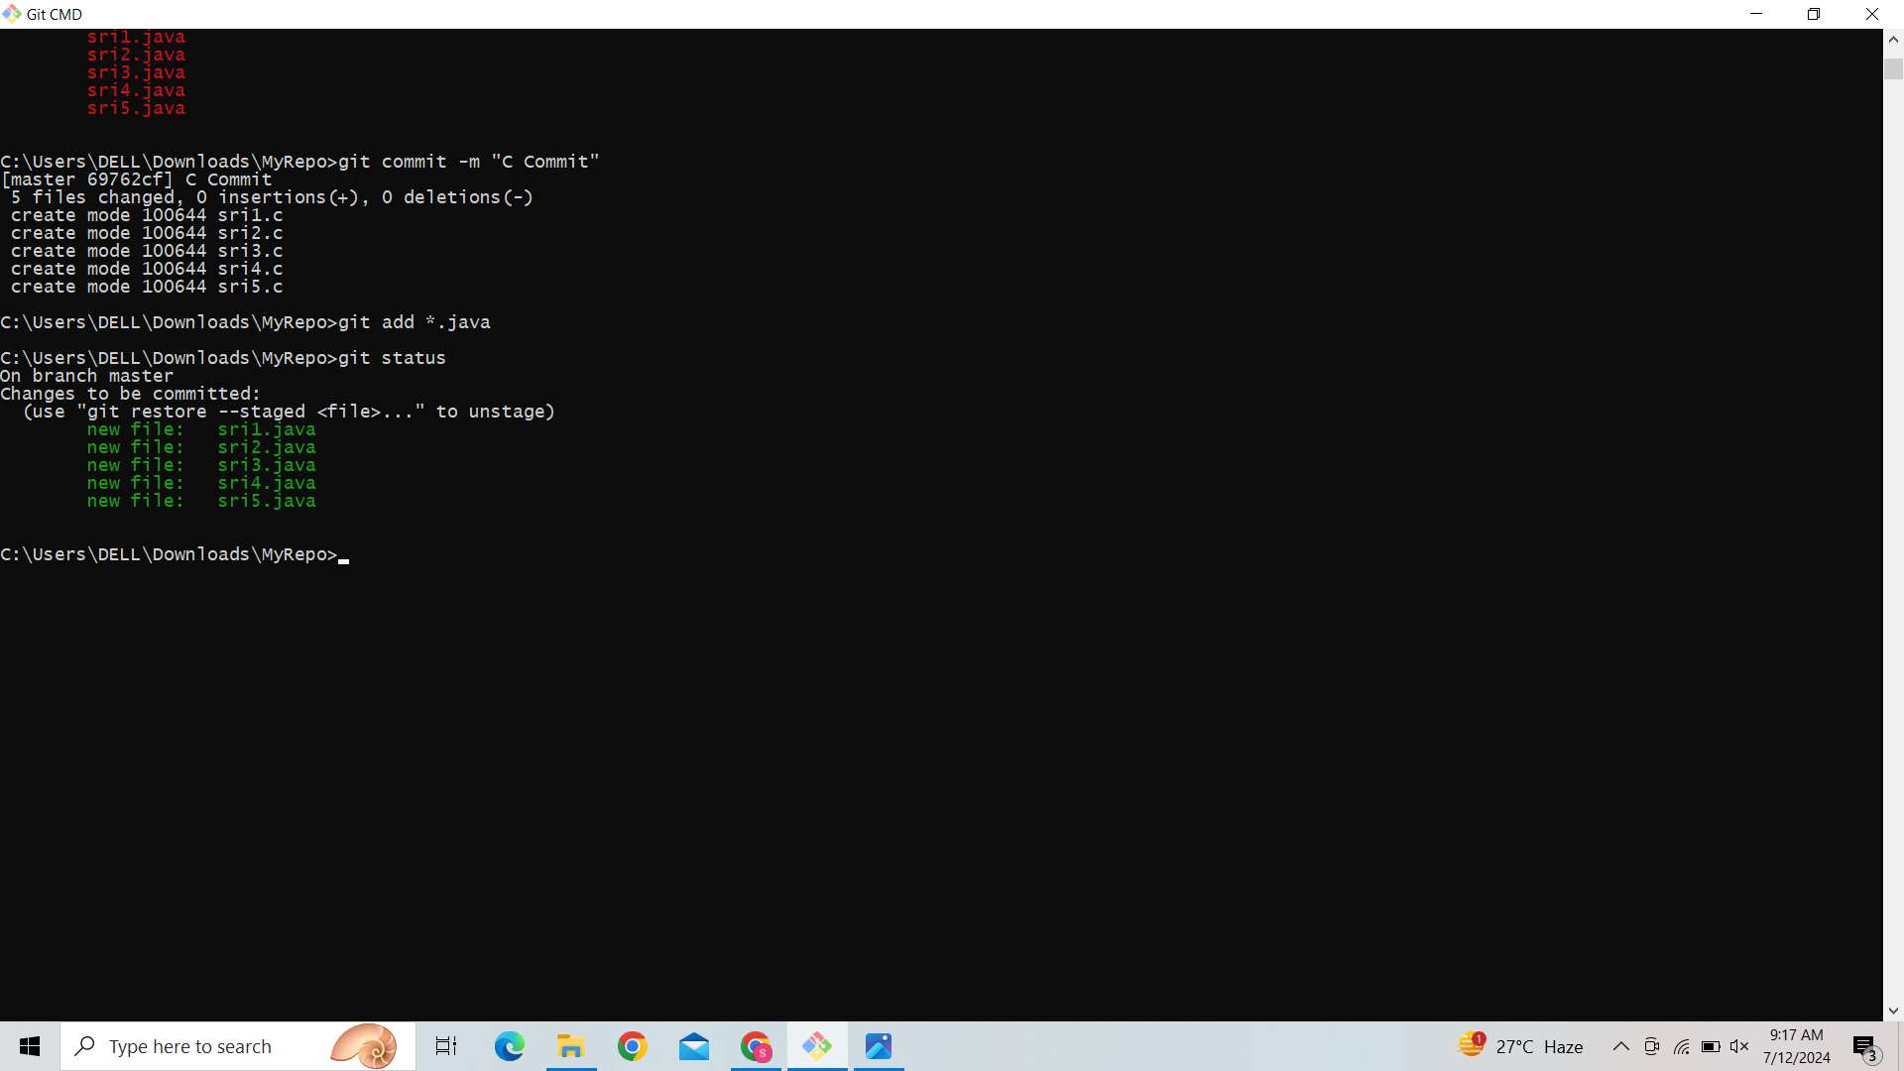

**11.** **verify the git status.**



**12. Make a commit with the name "Java Commit".**

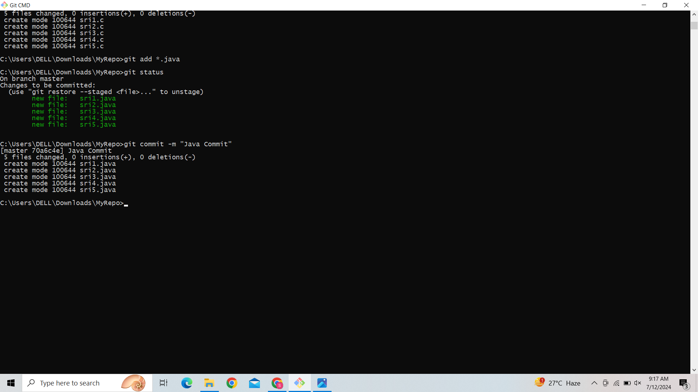

**13.Delete all .java files from working area.**

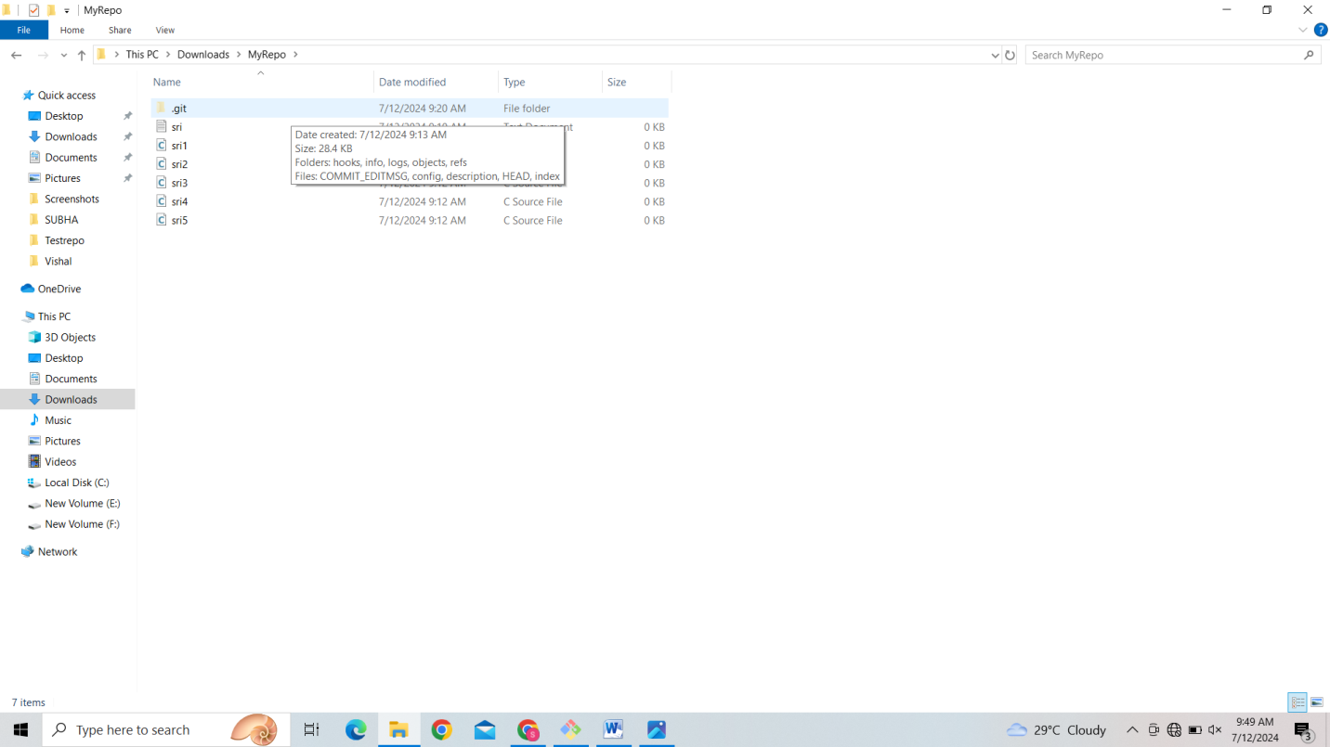

**14.** **Now see the status.**

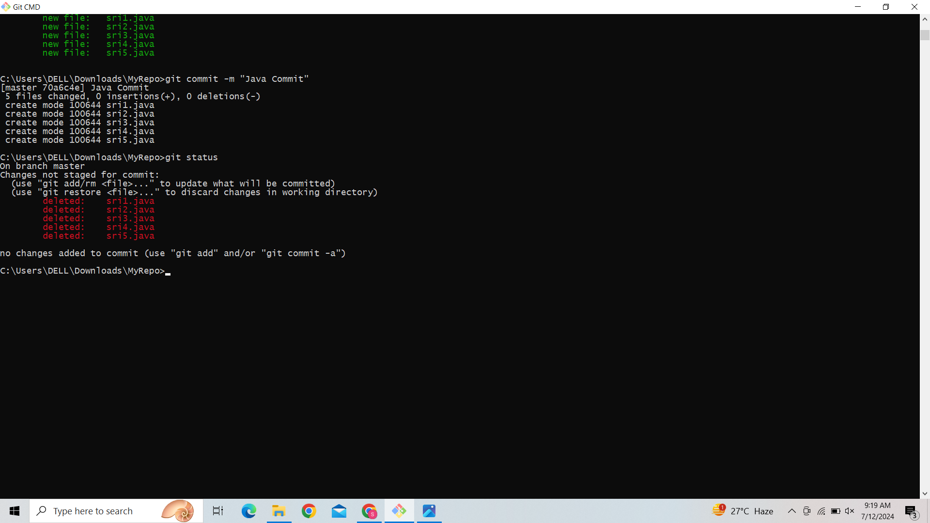

**15.** **Add the changes into the staging area.**

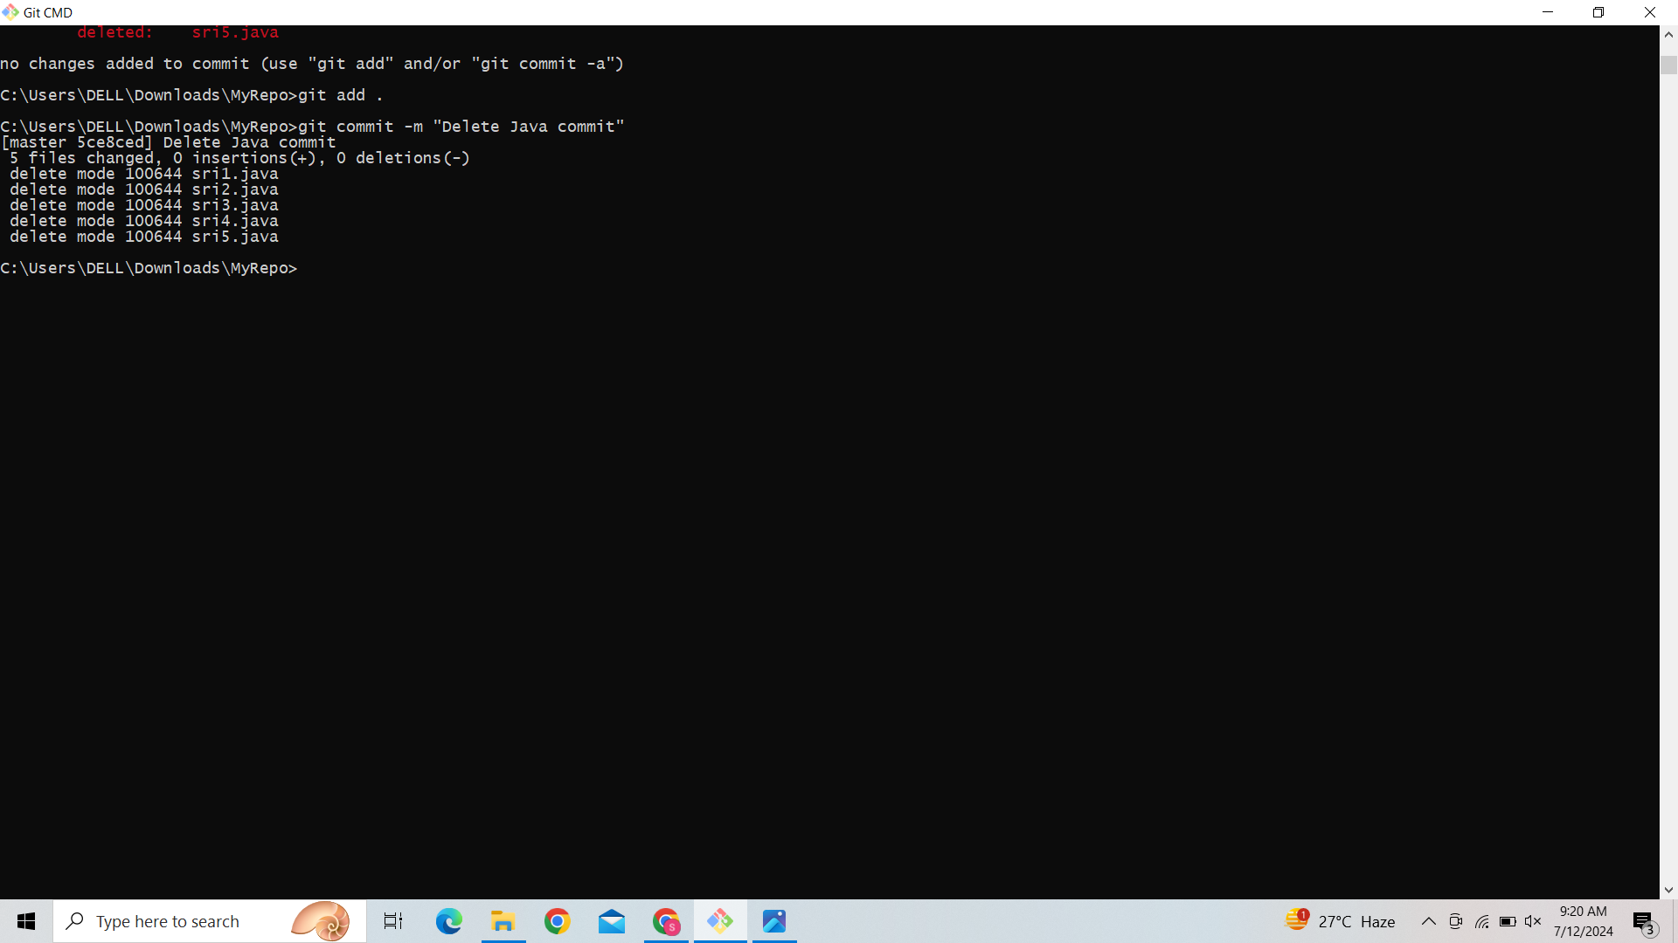

**16.**  **Make a commit with the name "Delete Java Commit".**



**17.Display all commit details.**

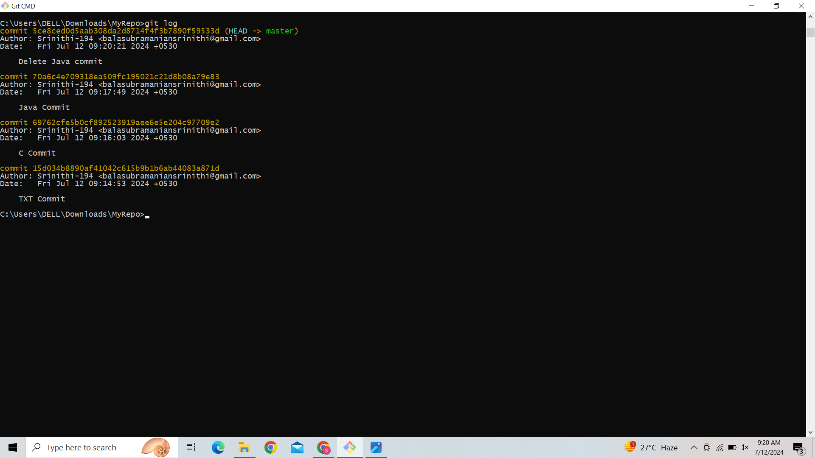

**Name :Srinithi B**

**Reg No :73772114210**

**Department:Computer Science and Engineering**

**Year :IV**